Name: Farwa Ahmad

Roll number: MCSF19M024

Subject: Mobile Computing Week 4

GitHub Link of Week 4 practice applications: [MC_Progress/04WeekApplications at master · farwa-ahmad/MC_Progress (github.com)](https://github.com/farwa-ahmad/MC_Progress/tree/master/04WeekApplications)

Lecture 6 – Intent

Lecture 7 – Activity Lifecycle

1. Made first activity. Arranged Views in Linear Layout and formatted them.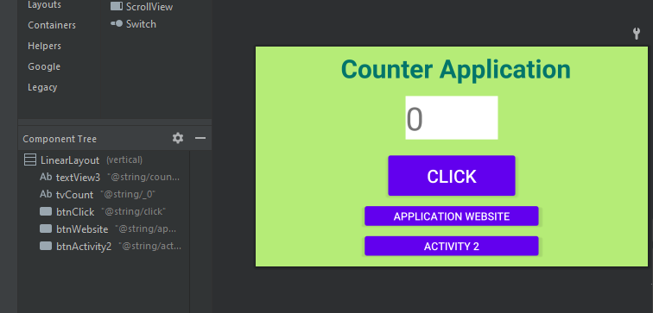

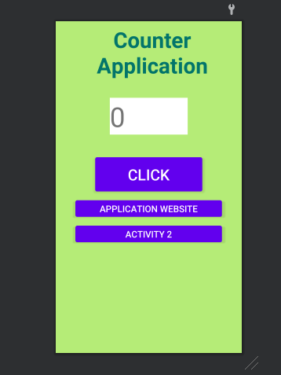

1. Made second activity. Arrange a TextView in Constraint Layout and designed the screen.

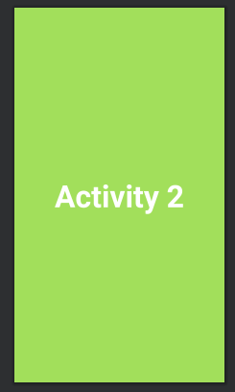

1. Renamed View IDs for easy identification

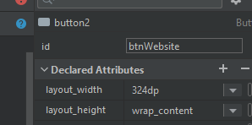

1. Creating hardcore resources (Click ALT + ENTER)

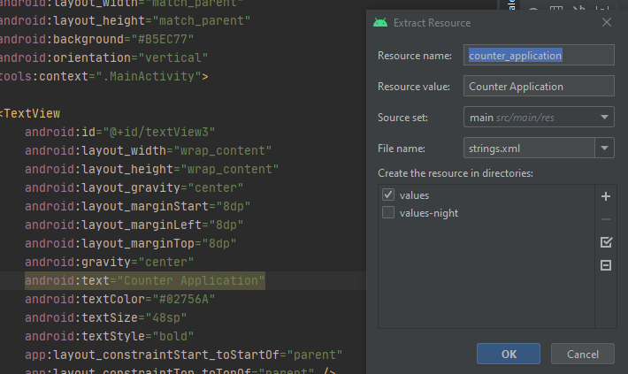

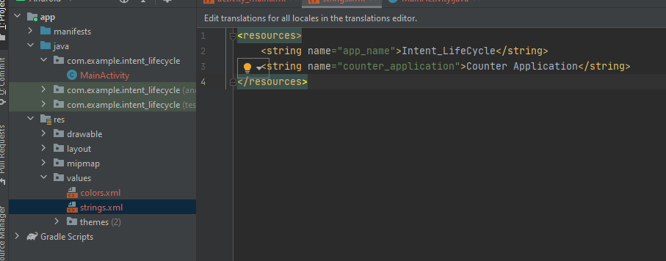

1. MainActivity code:

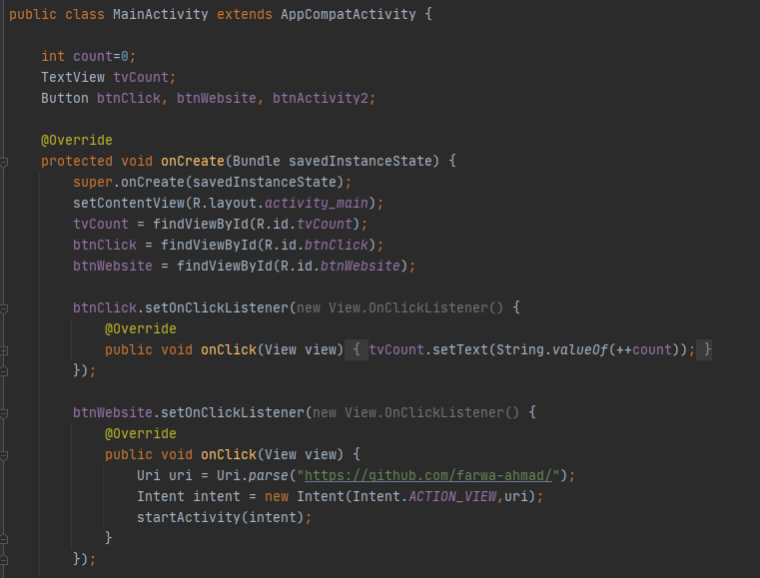

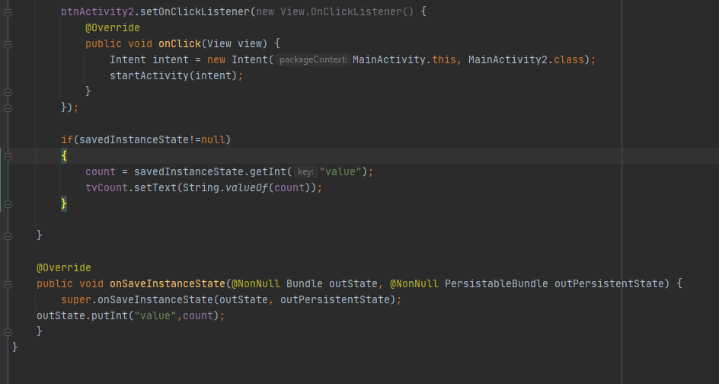

1. MainActivity2 Code:

